*Lstm:*

ITM

mse: 113638.57621146868

mae: 226.82447329468988

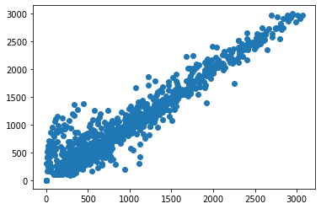

OTM

mse: 2750.386451851881

mae: 30.635190720047788

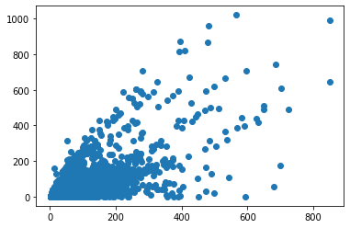

ATM

mse: 5065.4136339861225

mae: 45.78919763969382

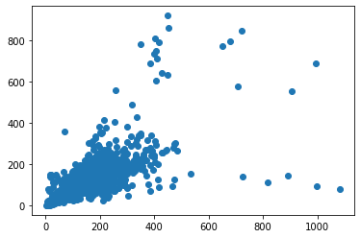

Deep ITM

mse: 14291616.319190143

mae: 3726.17676056338

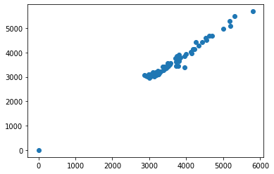

Deep OTM  
mse: 26.4453125

mae: 3.44375

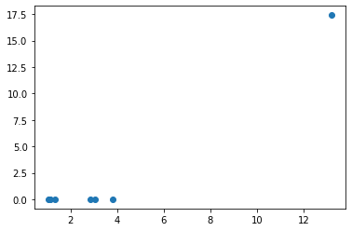

*Lstm_on_Resources:*

ITM

mse: 250.00696186729925

mae: 116797.5955344922

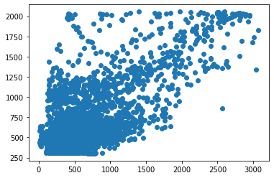

OTM

mse: 60.067698211962835

mae: 7653.617592967283

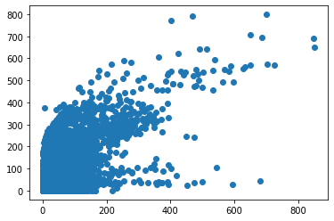

ATM

mse: 103.26240101090814

mae: 21520.577827583915

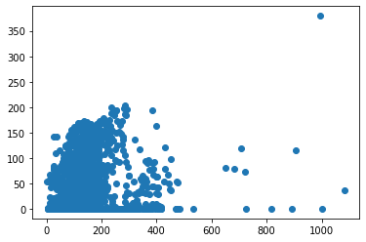

*Black_scholes_model_mlp_svol:*

ITM

Mae = 214.7474538518621

Mse = 105987.08619427329

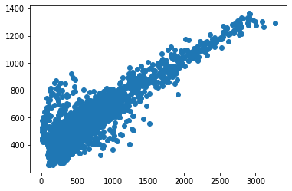

OTM

Mae = 44.686611456871724

Mse = 5421.2784905634335

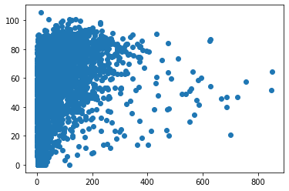

ATM

Mae = 141.35714285714286

Mse = 30961.08561398176

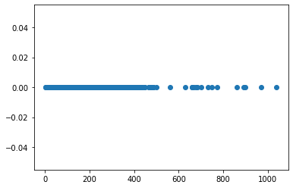

*Black_scholes_model_mlp_resources*

ITM

Mae = 78.7491361909244

Mse = 15776.63151964598

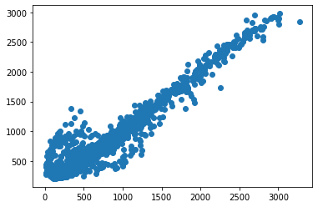

OTM

Mae = 60.74307186940076

Mse = 10446.681268664146

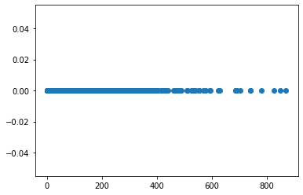

ATM

Mae =142.30447667087012

Mse = 29987.206901008823

